**Amazon S3**

**Topics:** S3 objects, versioning, encryption (SSE-S3, SSE-KMS, SSE-C, Client Side Encryption), S3 security, S3 bucket policies and settings, S3 website, S3 CORS, S3 consistency model

**S3 objects:** Amazon Simple Storage Service (Amazon S3) is an object storage service that offers industry-leading scalability, data availability, security, and performance. This means customers of all sizes and industries can use it to store and protect any amount of data for a range of use cases, such as websites, mobile applications, backup etc. Amazon S3 is designed for 99.999999999% (11 9's) of durability, and stores data for millions of applications for companies all around the world.

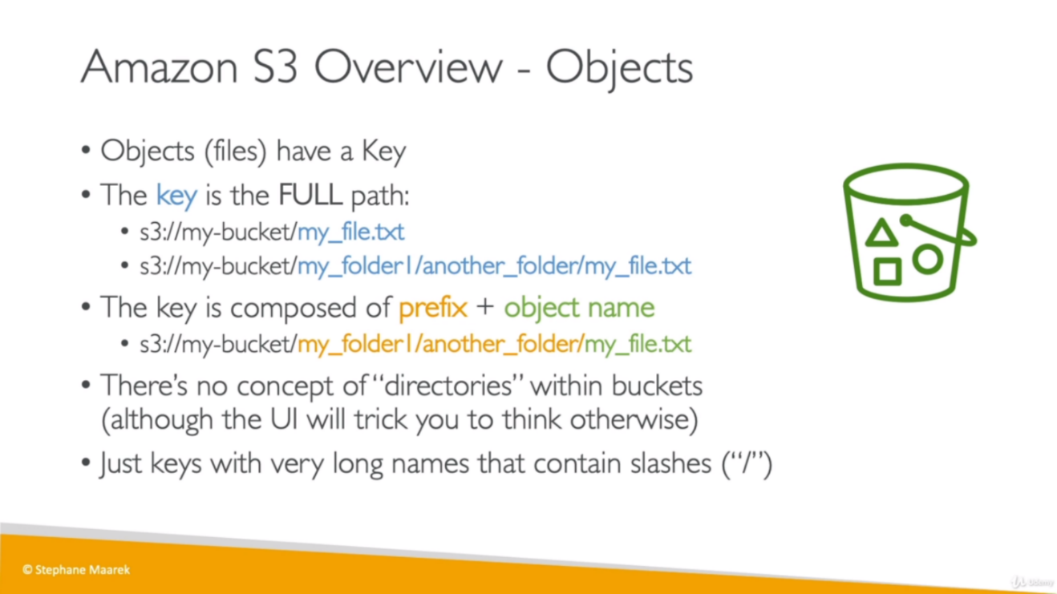

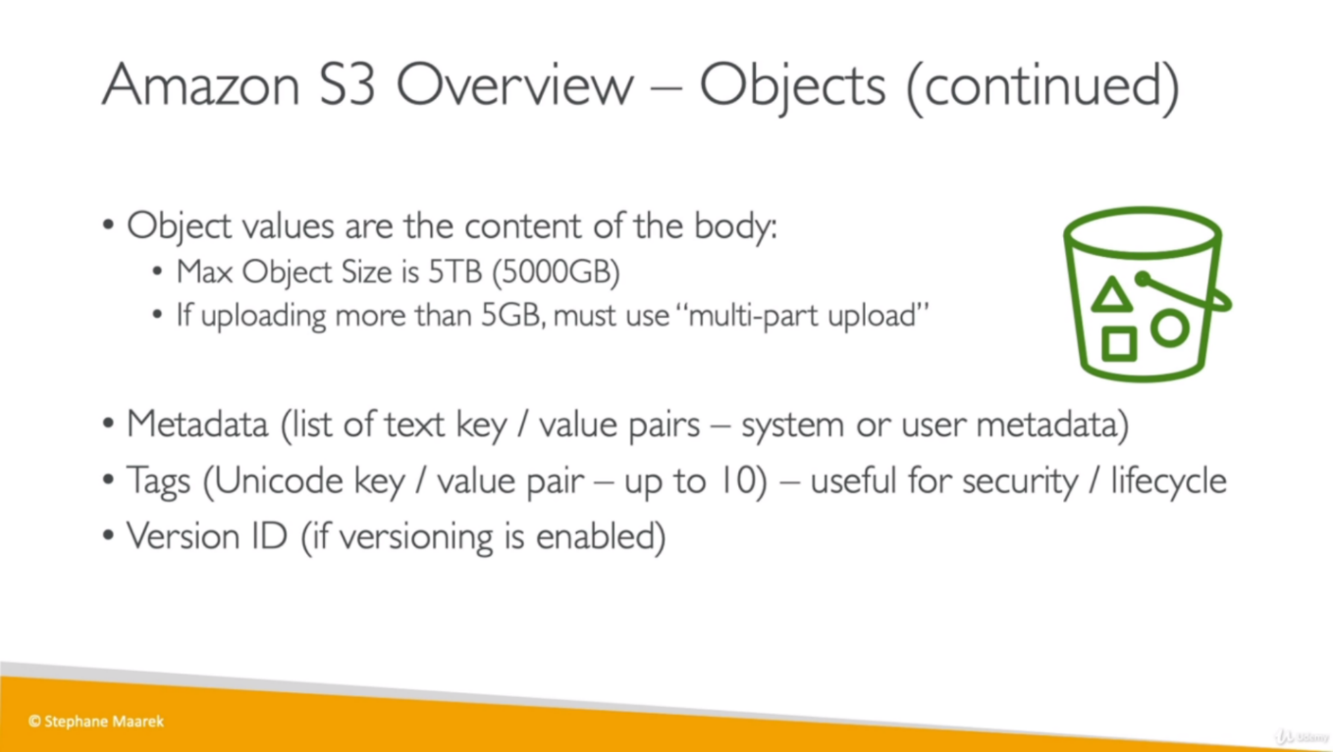

**Create a Bucket:**

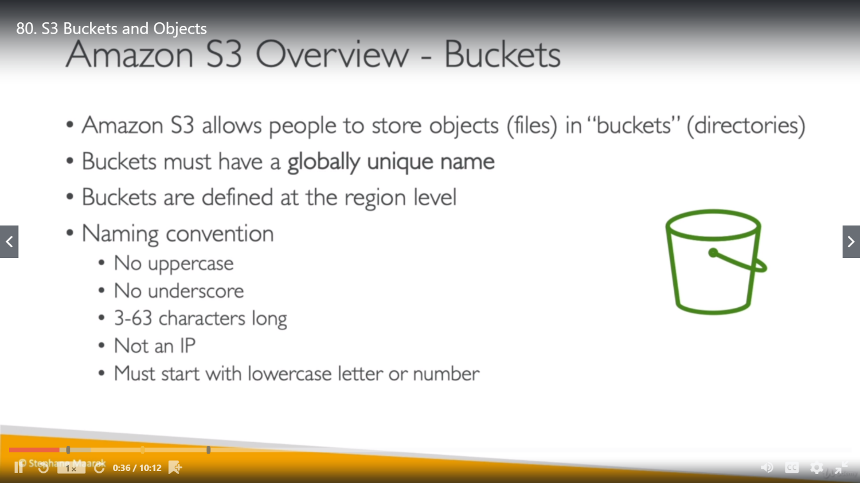

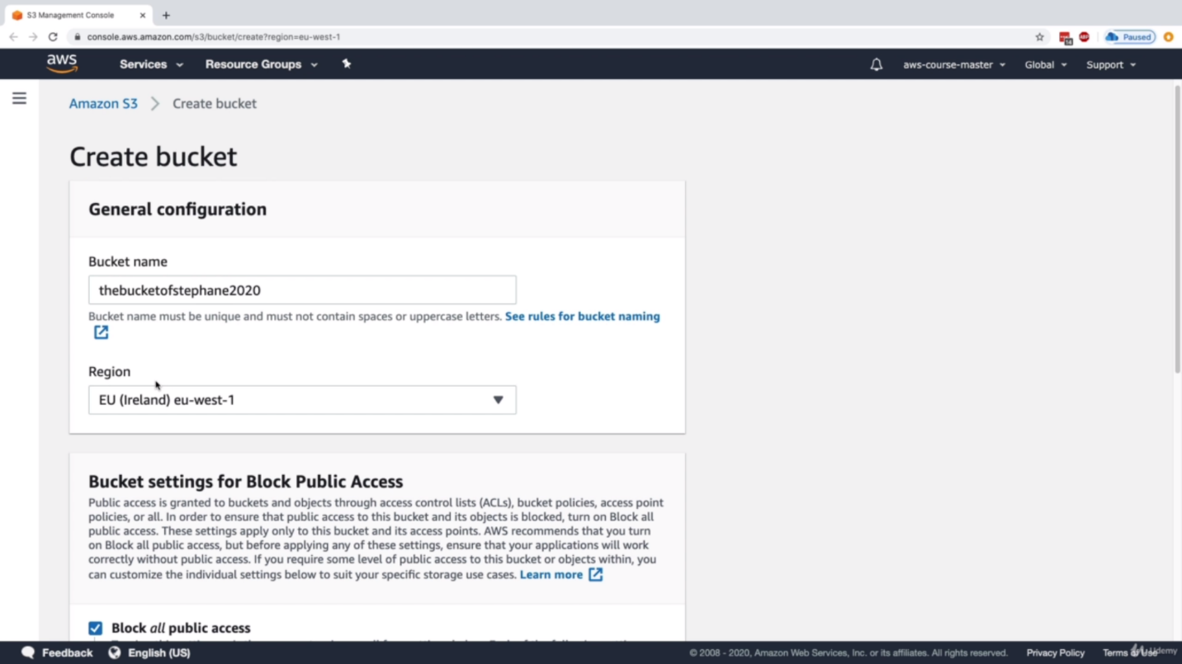

**Amazon S3 versioning:**

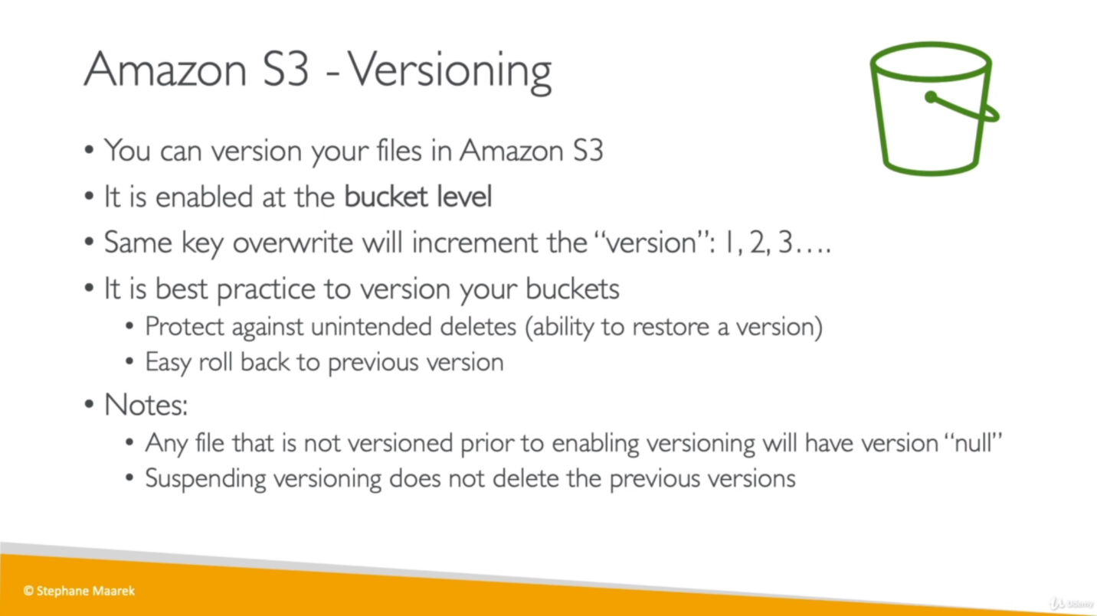

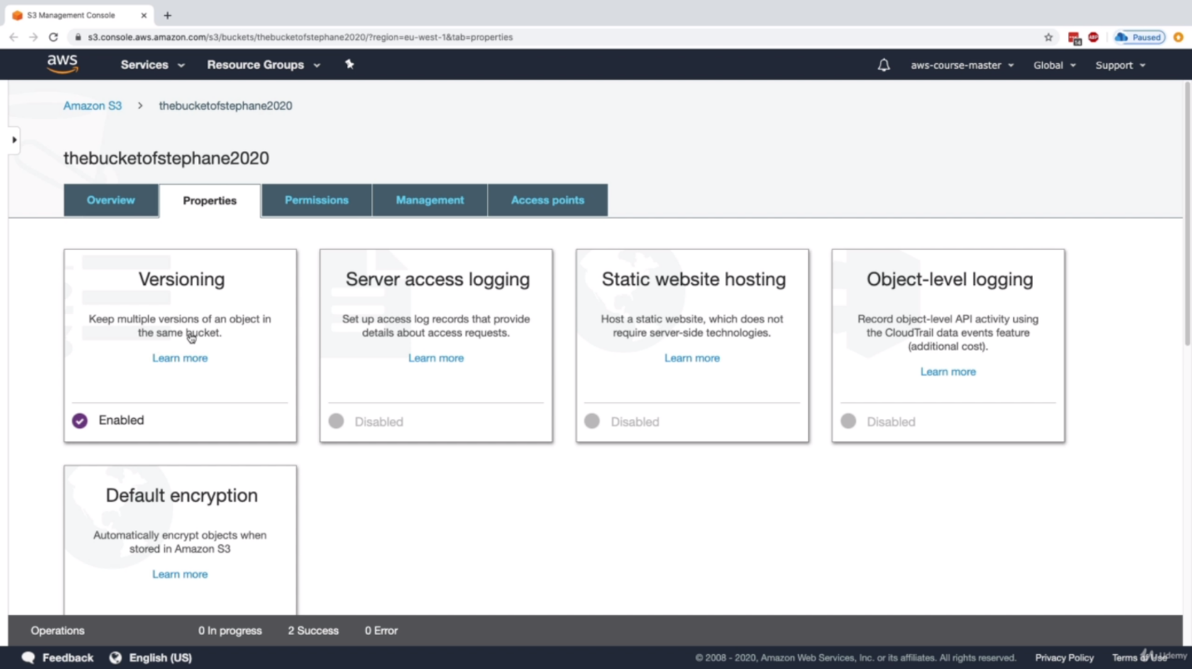

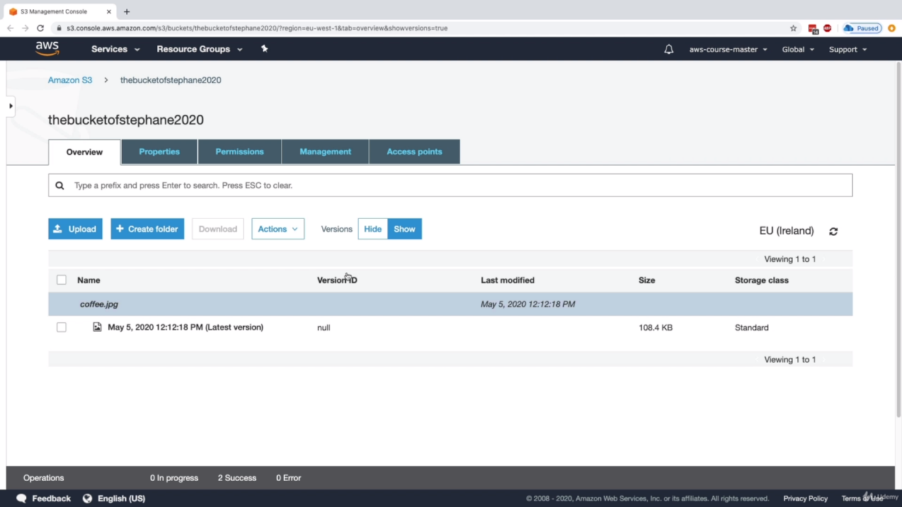

If we delete a versioned file from bucket, it will be deleted from there but if check “versions: show”, it will be marked as “Delete marker” so we can either delete or restore it from there.

If we delete “Delete marker” file, previous version will become the latest version and file will appear in with “versions: hide”.

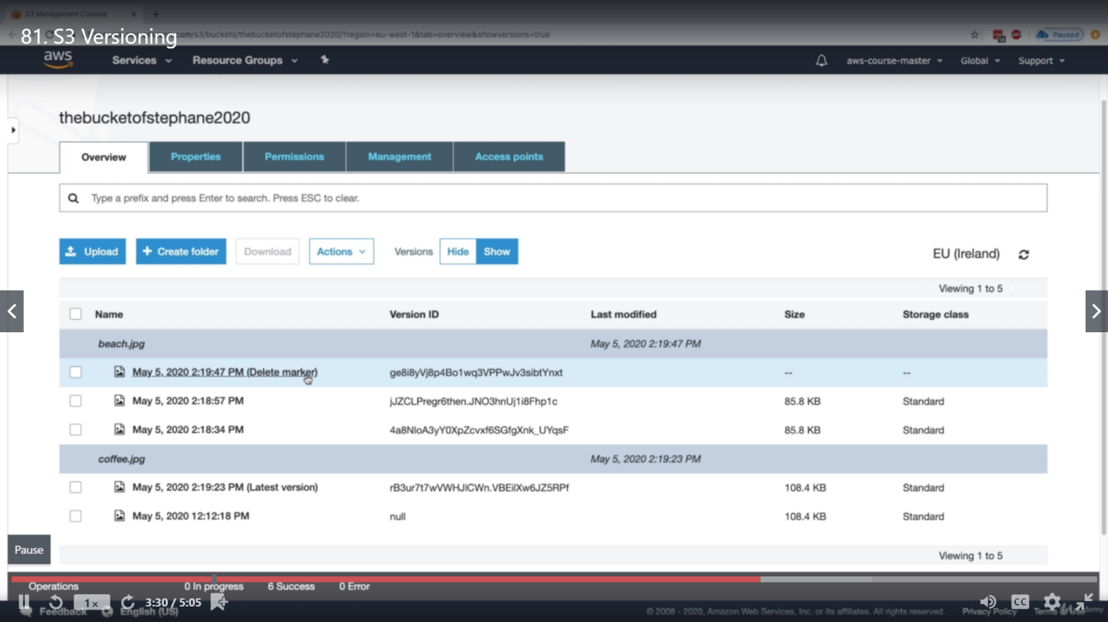

**S3 Encryption for Object**

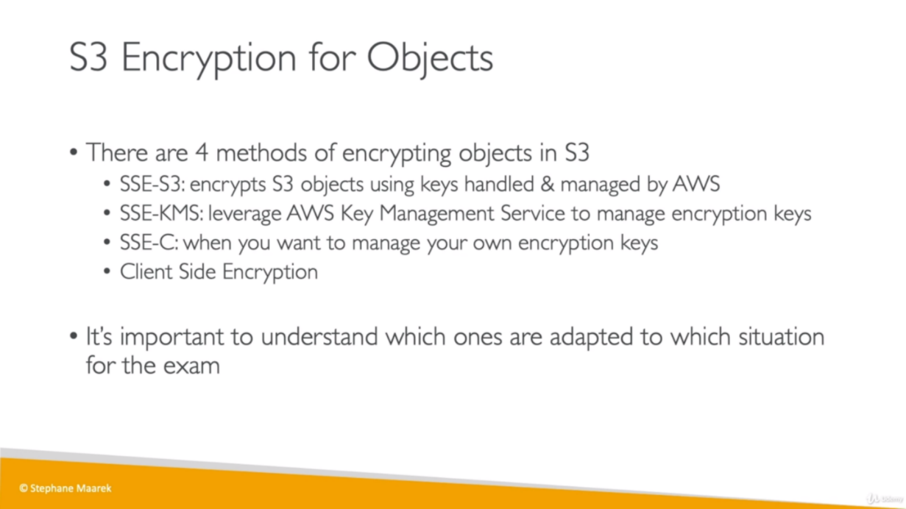

1. **SSE S3:** Server Side Encryption with amazon S3 managed key.

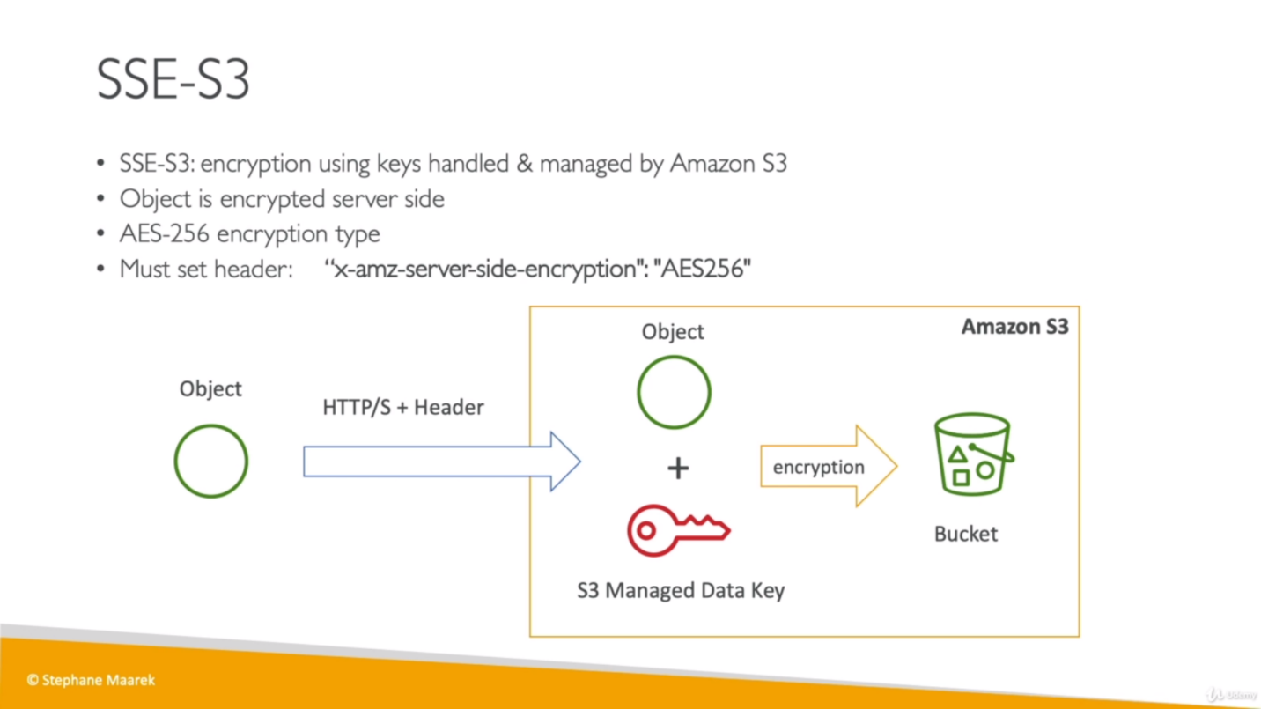

Server-side encryption protects data at rest. Amazon S3 encrypts each object with a unique key. As an additional safeguard, it encrypts the key itself with a master key that it rotates regularly.

Amazon S3 server-side encryption uses one of the strongest block ciphers available to encrypt our data, *256-bit Advanced Encryption Standard* (AES-256).

If we need server-side encryption for all of the objects that are stored in a bucket, use a bucket policy which denies permissions to upload an object unless the request includes **the x-amz-server-side-encryption** header to request server-side encryption.

Server-side encryption encrypts only the object data, not object metadata.

While uploading the object, we can choose SSE S3 option as below (in Set properties)

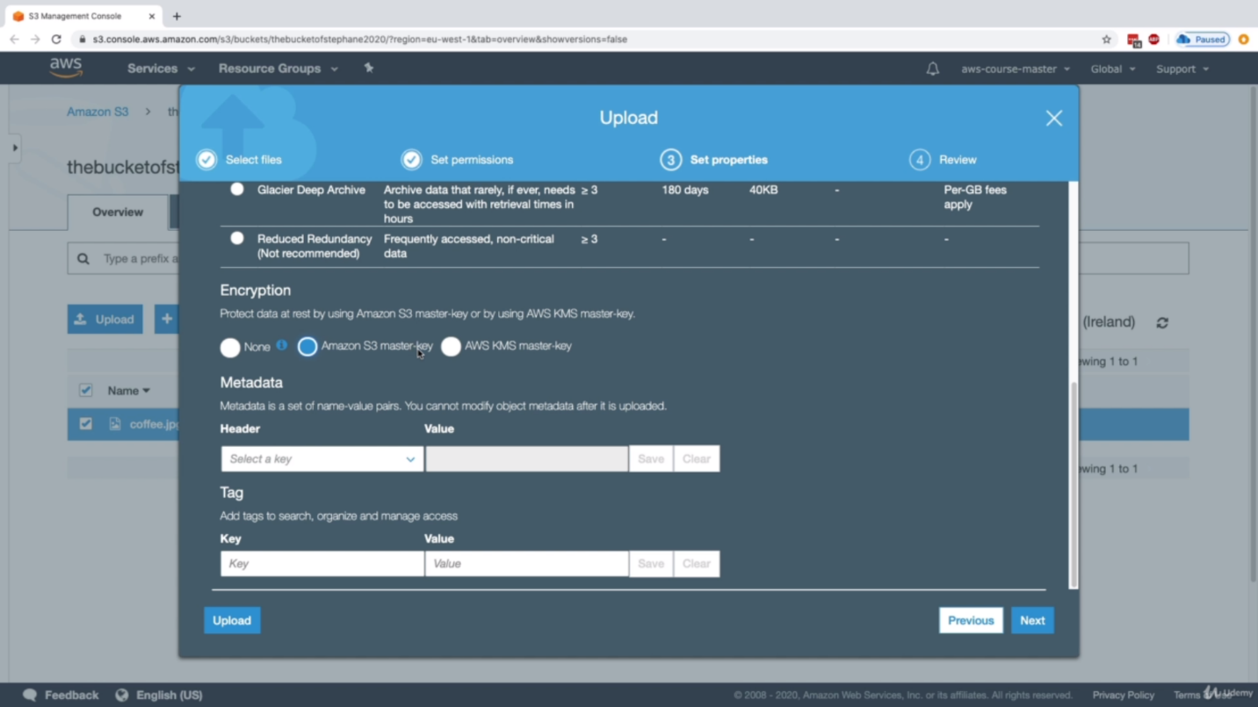

Now with details of object, it will show that Encryption as AES-256.

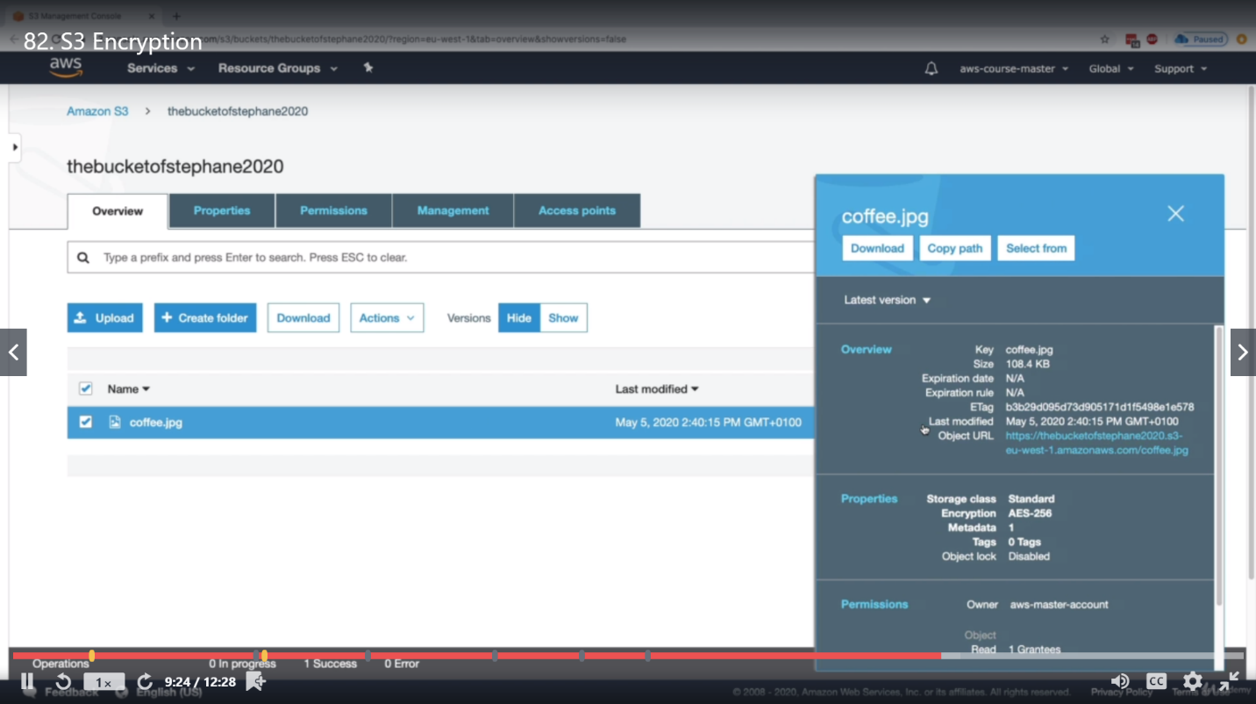

1. **SSE-KMS:** server-side encryption with Key Management Service

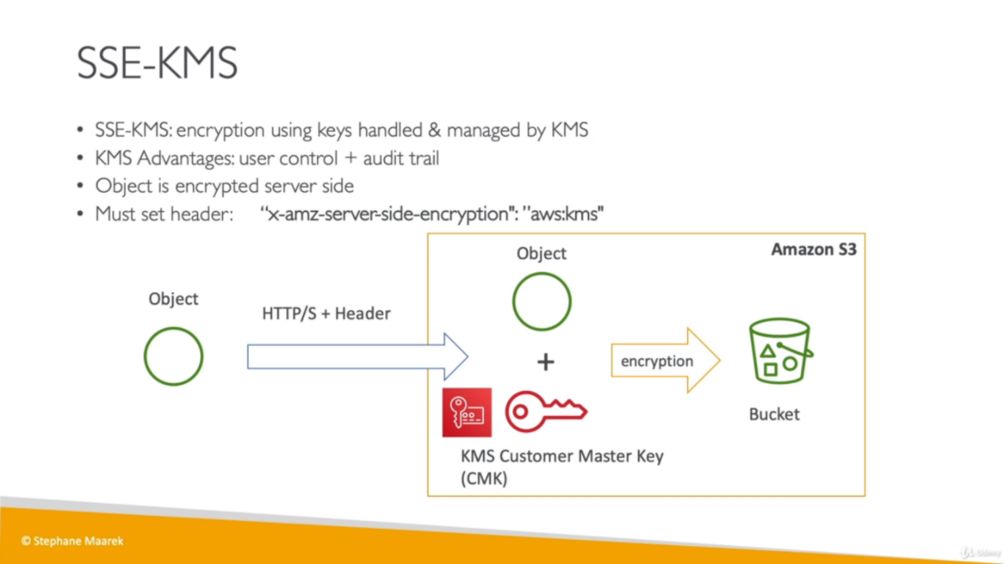

AWS Key Management Service (AWS KMS) is a service that combines secure, highly available hardware and software to provide a key management system scaled for the cloud. Amazon S3 uses AWS KMS customer master keys (CMKs) to encrypt your Amazon S3 objects.

This can be used when: Your company wants data to be encrypted in S3 and maintain control of the rotation policy for the encryption keys. To create new cryptographic material for your AWS KMS CMKs, you can create new CMKs, and then change your applications or aliases to use the new CMKs. Or, you can enable automatic key rotation for an existing [customer managed CMK](https://docs.aws.amazon.com/kms/latest/developerguide/concepts.html#customer-cmk). When you enable automatic key rotation for a customer managed CMK, AWS KMS generates new cryptographic material for the CMK every year. AWS KMS also saves the CMK's older cryptographic material in perpetuity (quality of lasting forever), so it can be used to decrypt data that it encrypted. AWS KMS does not delete any rotated key material until you [delete the CMK](https://docs.aws.amazon.com/kms/latest/developerguide/deleting-keys.html).

AWS KMS encrypts only the object data. Any object metadata is not encrypted.

**KMS Limitation:** *GenerateDataKey* and *Decrypt* KMS APSs are used for upload and download.

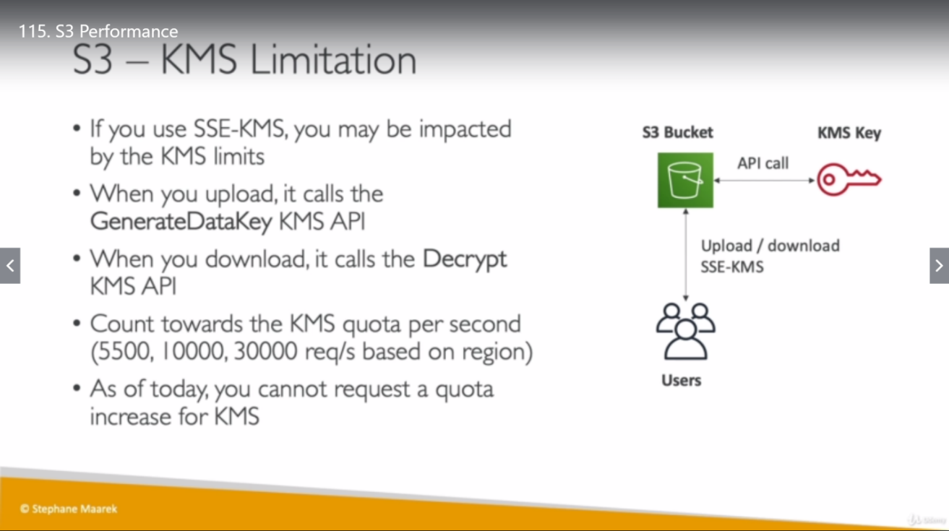

1. **SSE-C:** server-side encryption with customer-provided encryption keys.

Using server-side encryption with customer-provided encryption keys (SSE-C) allows us to set our own encryption keys. With the encryption key we provide as part of our request, Amazon S3 manages the encryption as it writes to disks and decryption when we access our objects. Therefore, we don't need to maintain any code to perform data encryption and decryption. The only thing we do is manage the encryption keys that we provided.

Server-side encryption encrypts only the object data, not object metadata.

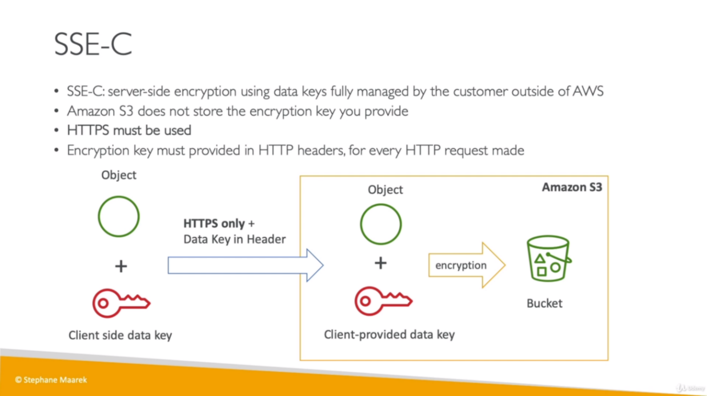

we must use HTTPS.

**Important**

Amazon S3 rejects any requests made over HTTP when using SSE-C

The ETag in the response is not the MD5 of the object data.

We manage a mapping of which encryption key was used to encrypt which object. Amazon S3 does not store encryption keys. We are responsible for tracking which encryption key we provided for which object.

If our bucket is versioning-enabled, each object version you upload using this feature can have its own encryption key. We are responsible for tracking which encryption key was used for which object version.

Because we manage encryption keys on the client side, we manage any additional safeguards, such as key rotation, on the client side.

**Warning**

If we lose the encryption key, any GET request for an object without its encryption key fails, and we lose the object.

1. **Client Side Encryption:**

*Client-side encryption* is the act of encrypting data before sending it to Amazon S3. To enable client-side encryption, you have the following options:

* Use a customer master key (CMK) stored in AWS Key Management Service (AWS KMS).
* Use a master key and store within our application.
* This can be used when company does not trust S3 for encryption and wants it to happen on the application.

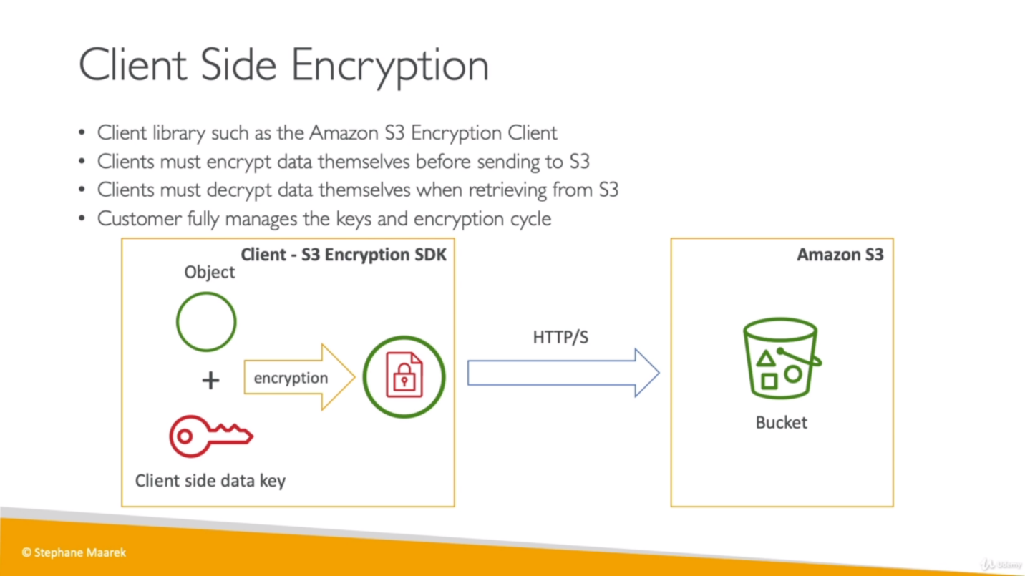

We can setup default encryption under properties folder and choose either none, AES-256 or AWS-KMS (even if we choose none while uploading the object, object will be encrypted with chosen encryption).

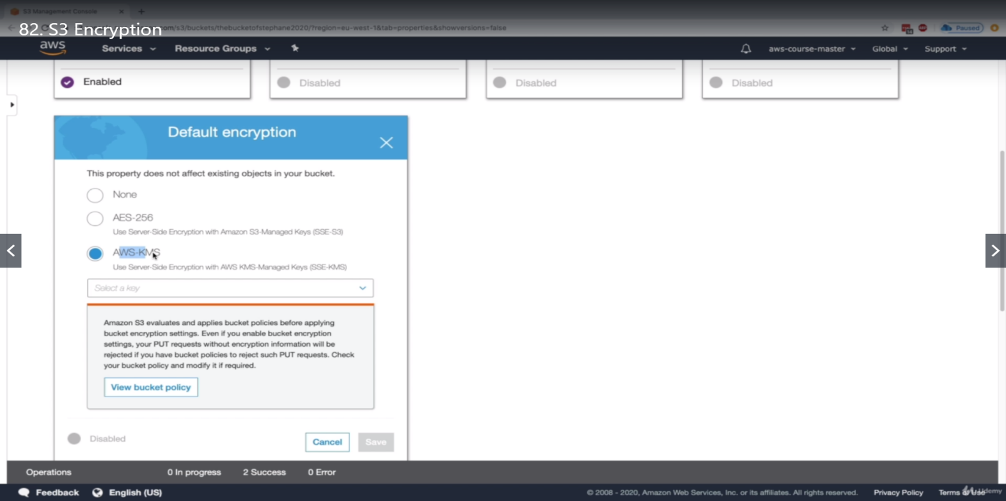

**S3 Security:** We can make sure that our objects in S3 buckets are secured and only specific users can access those objects which have required policies. Security can be restricted by uses or Resource both but in case contradiction resource based policies will get priority.

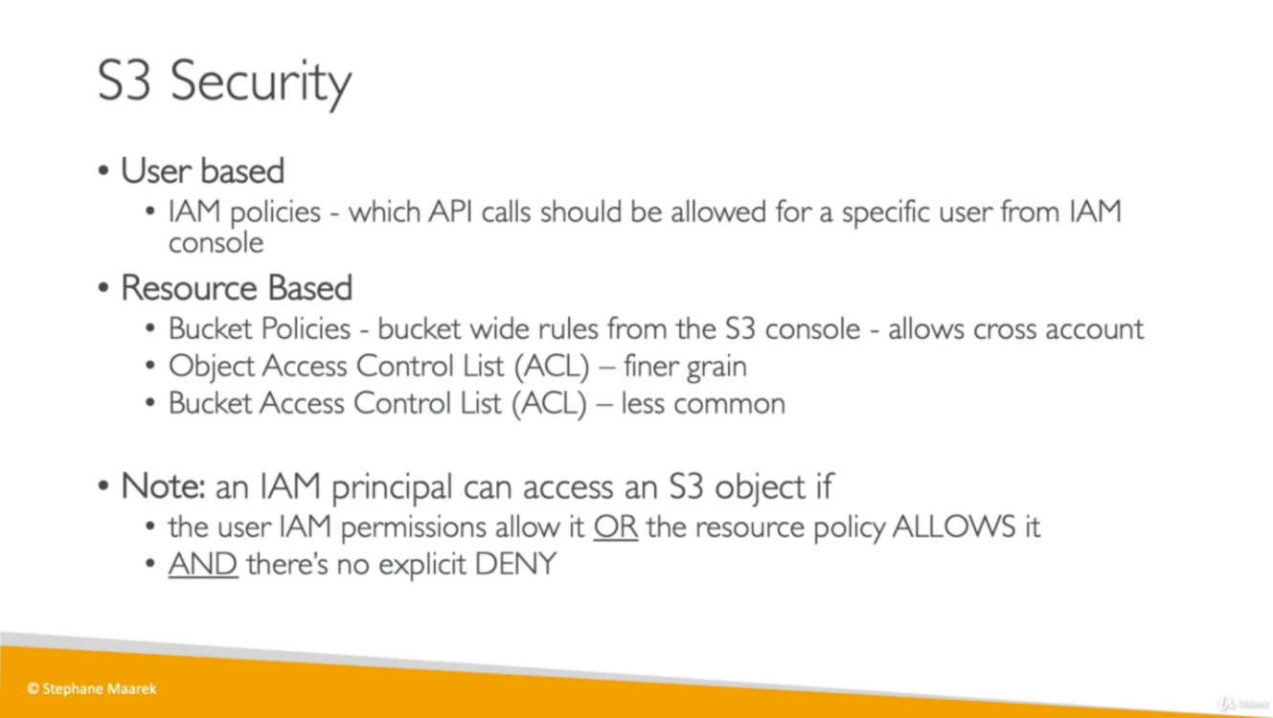

In Resource Based policies, there are bucket wise rules that allow a user to access an object and manage what a user can or can’t do on a bucket.

If IAM principle (user, role etc.), gives a permission for a user to access a S3 object but if bucket policy is explicitly denying user to access it then user will not be able to access it.

There are json based **s3 bucket policies** which allows to access the bucket/objects.

IAM security are always for effect: allow but resource security is for both effects: allow, deny.

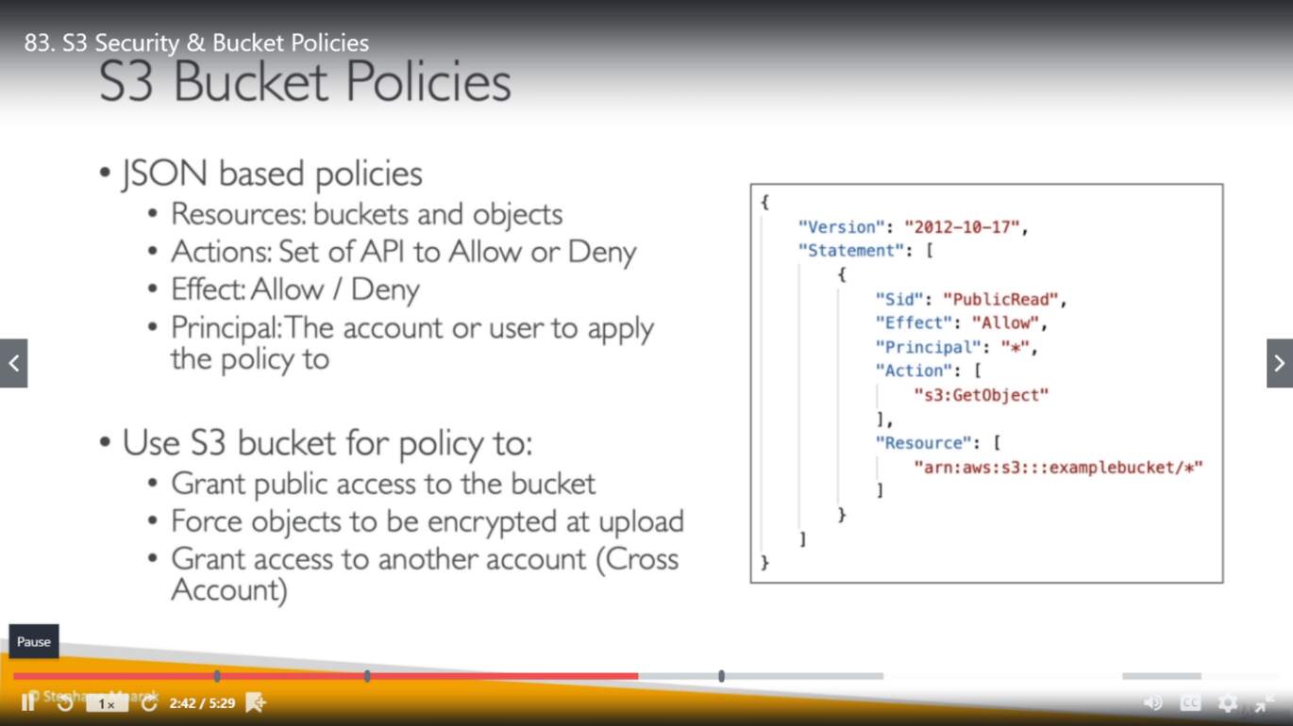

There are few other securities as well provided by AWS like, who can delete an object from S3 bucket, block public access on all/few buckets etc.

There is a way to block public access on our bucket by making some settings.

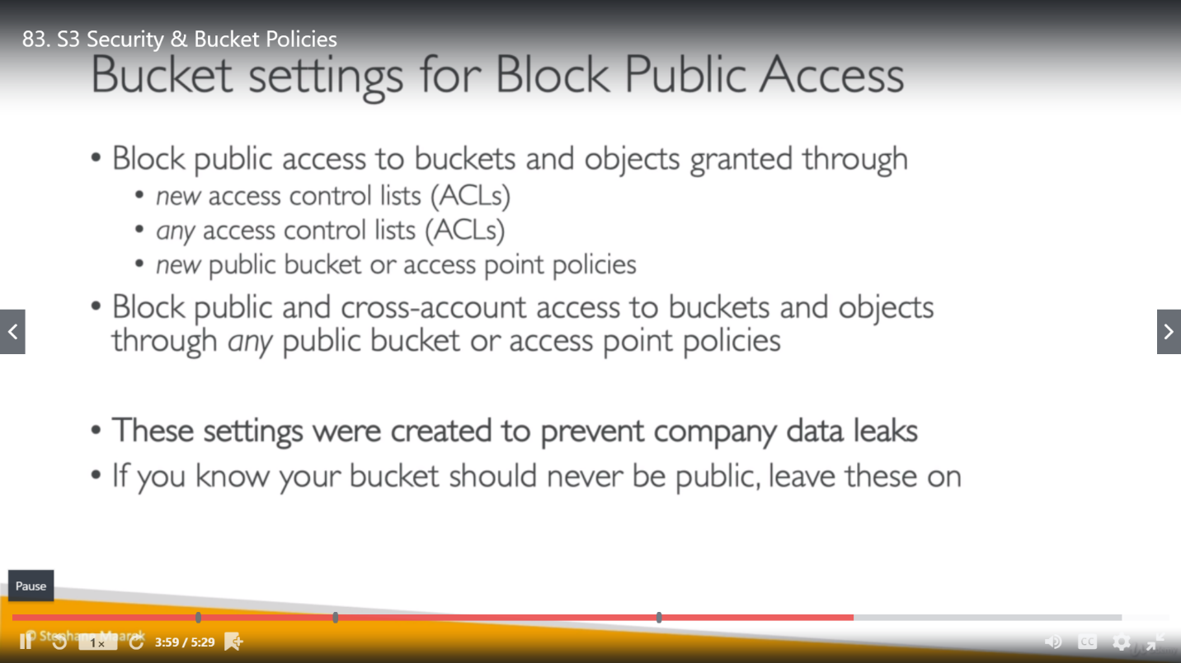

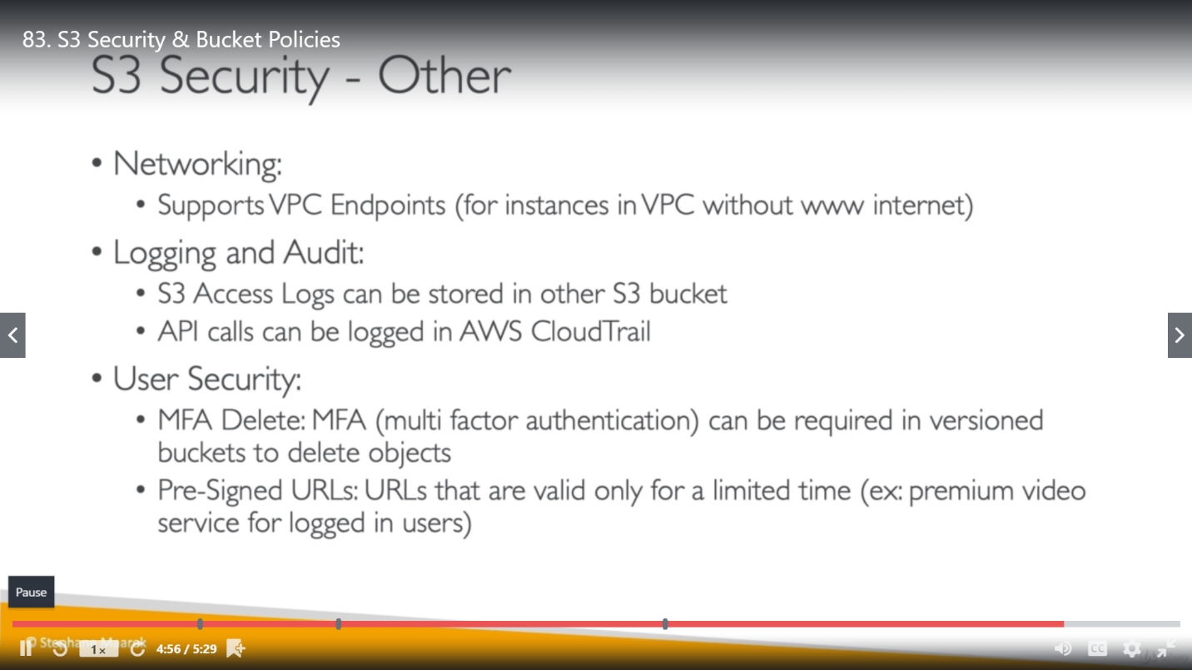

Below we created a Bucket Policy where all the request on S3 bucket will be denied.

Effect: deny

Principle: *

ARN: take bucket policy ARN (Amazon Resource Name) and add /* at the end and place it as ARN in policy.

Actions: put object

Conditions: null

Key: amz-server-side-encryption

Value: true

The meaning of last 3 condition is, if an object is uploaded without server side encryption then deny it.

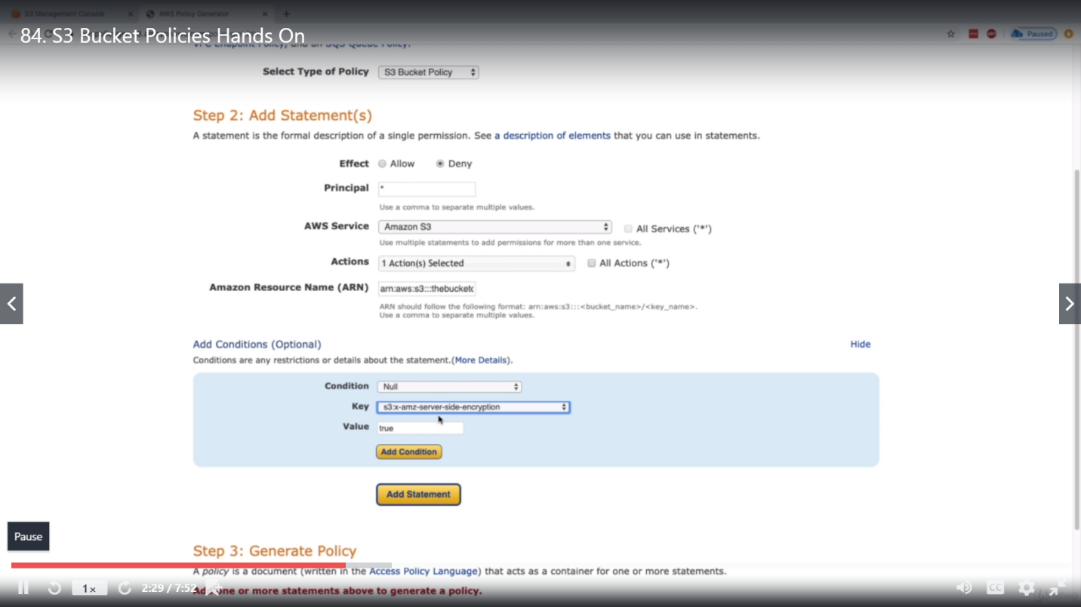

Other object with different condition where its request will deny for:

condition: StringNotEquals

Key: server-side-encryption

Value: AES256 (encryption for SSE S3)

So now we have two requests, we can click on generate policy button and it will give us json object (for both the condition together) which can be copied and pasted in bucket policy and save it.

**S3 website:** You can use Amazon S3 to host a static website. On a *static* website, individual webpages include static content. They might also contain client-side scripts.

By contrast, a *dynamic* website relies on server-side processing, including server-side scripts such as PHP, JSP, or ASP.NET. Amazon S3 does not support server-side scripting, but AWS has other resources for hosting dynamic websites.

Step for static website: add an index.html and error.html and make below changes.

1. Create a policy to access this static website
2. Disable Block policy

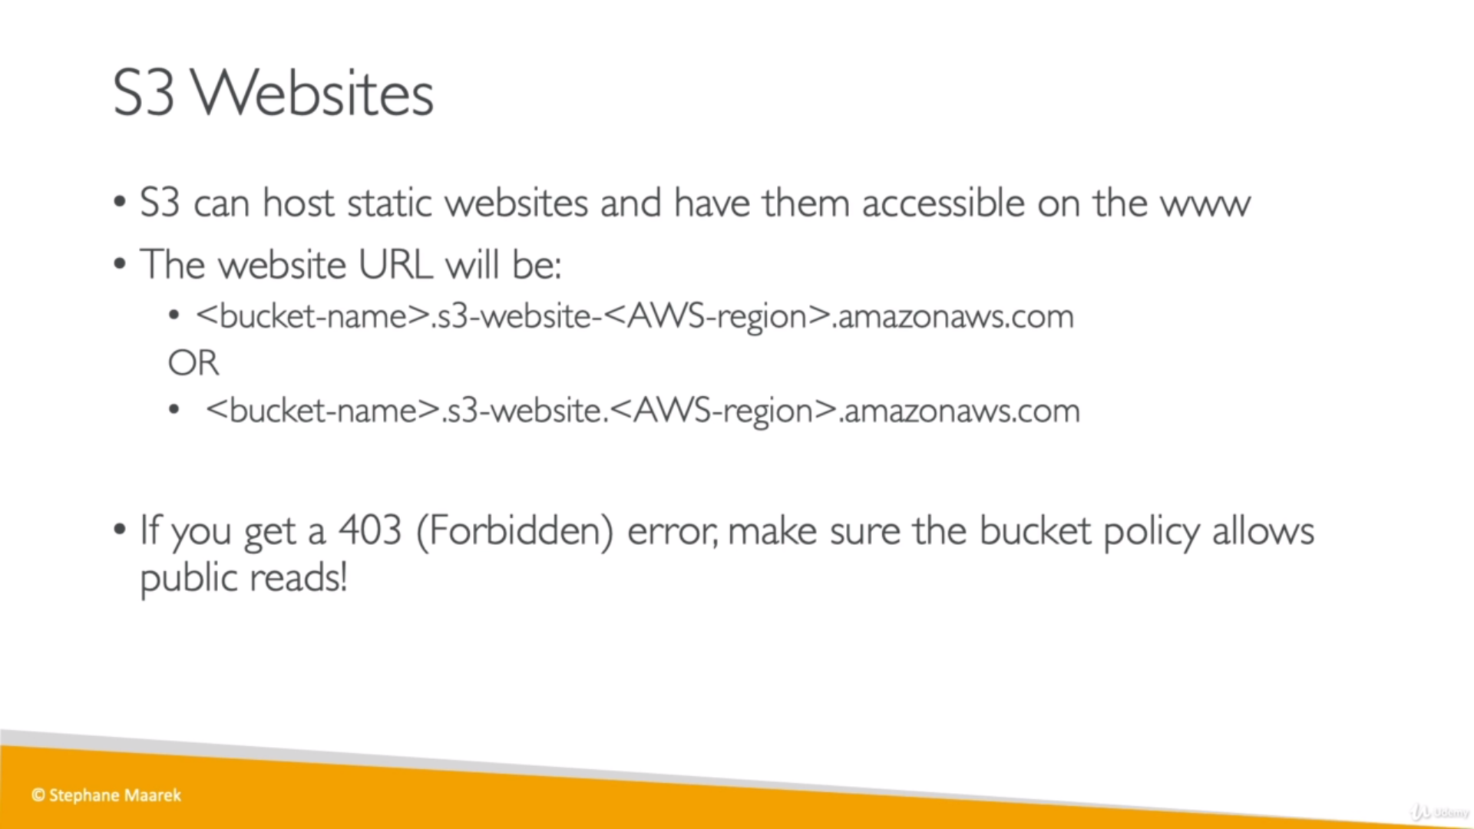

**CORS: Cross Origin Resource Sharing (**Get resources from different origin**)**

Web browser are having this security in place basically saying that as soon as we reach a website, we can make request to other origins only if the other origin allows us to make these requests.

**Origin: scheme + host + port**

Scheme also known as protocol and host also known as domain.

Ex: <https://www.google.com>, here https is a scheme, [www.google.com](http://www.google.com) is a host . (HTTPS default port is 443 and for HTTP 80).

Once a request goes from one origin to another, browser need CORS policy enable in 2nd origin else it won’t fulfil the request. For ex: If a request in going from [www.google.com](http://www.google.com) to [www.example.com](http://www.example.com) it need CORS enable in website code.

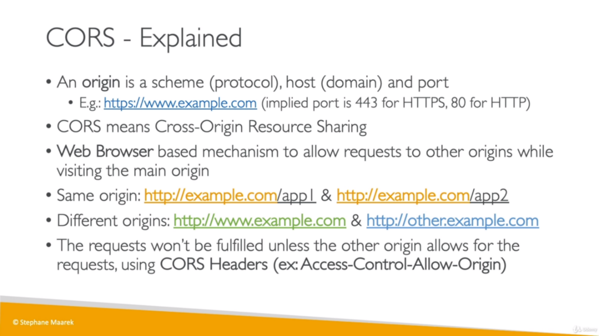

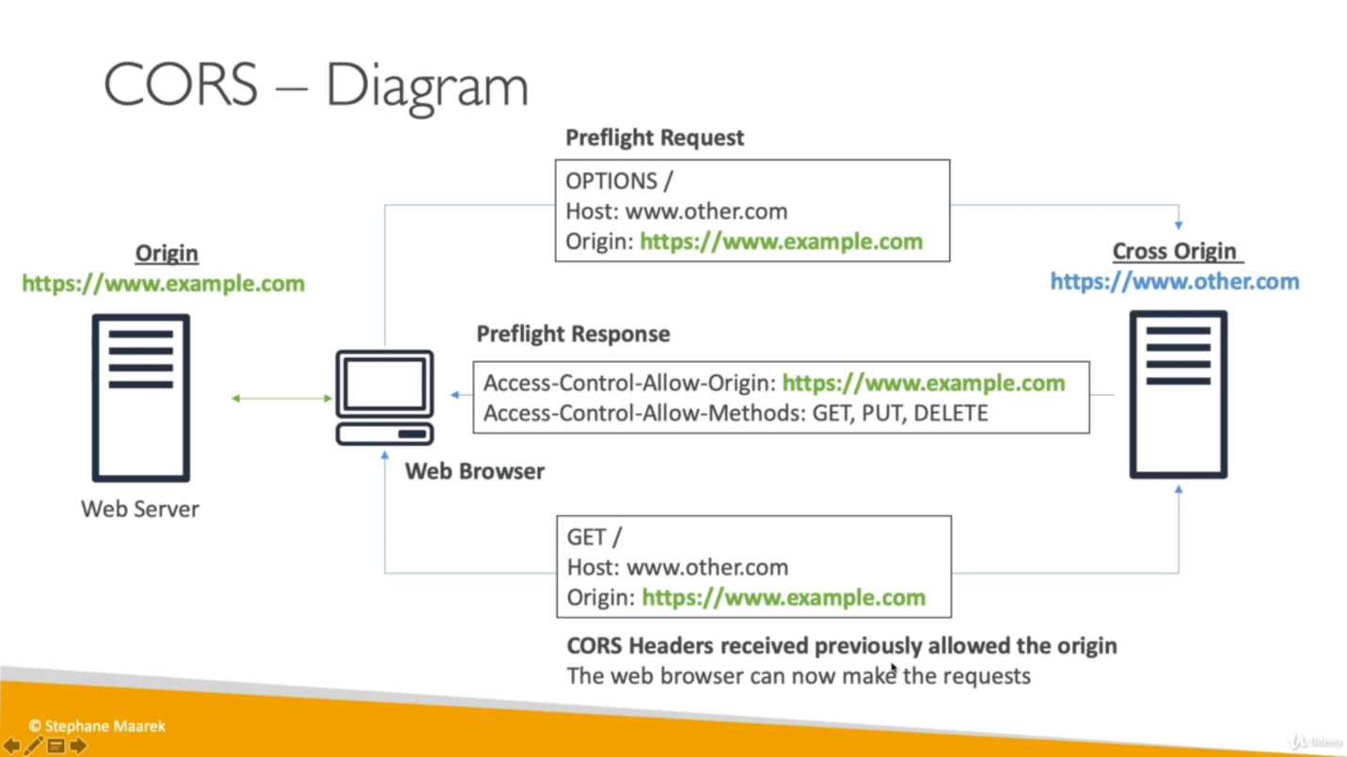

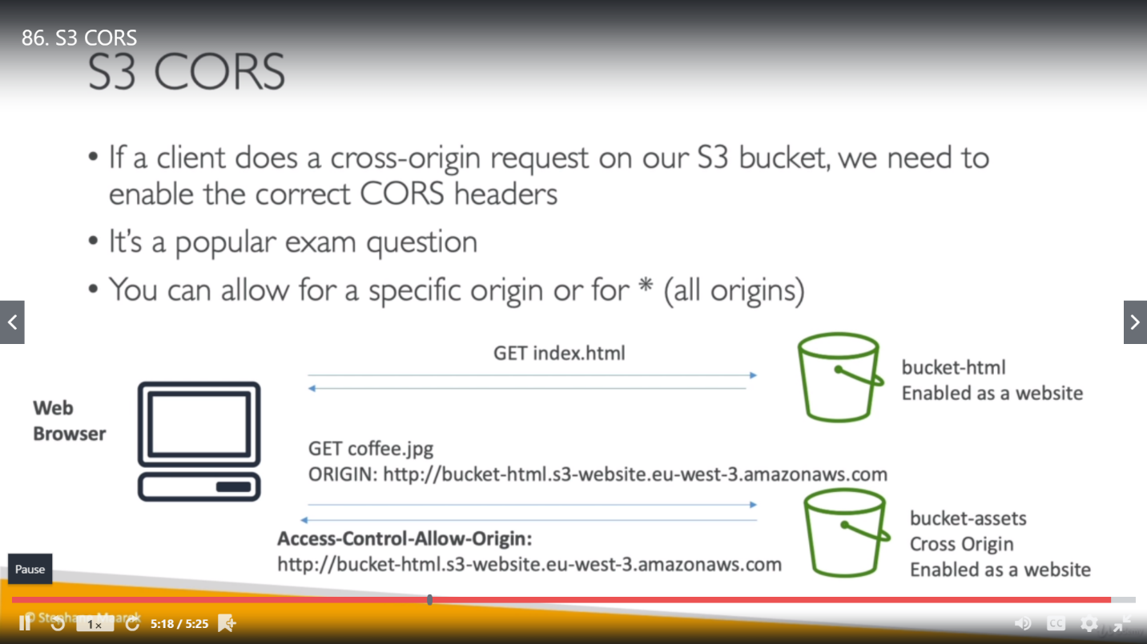

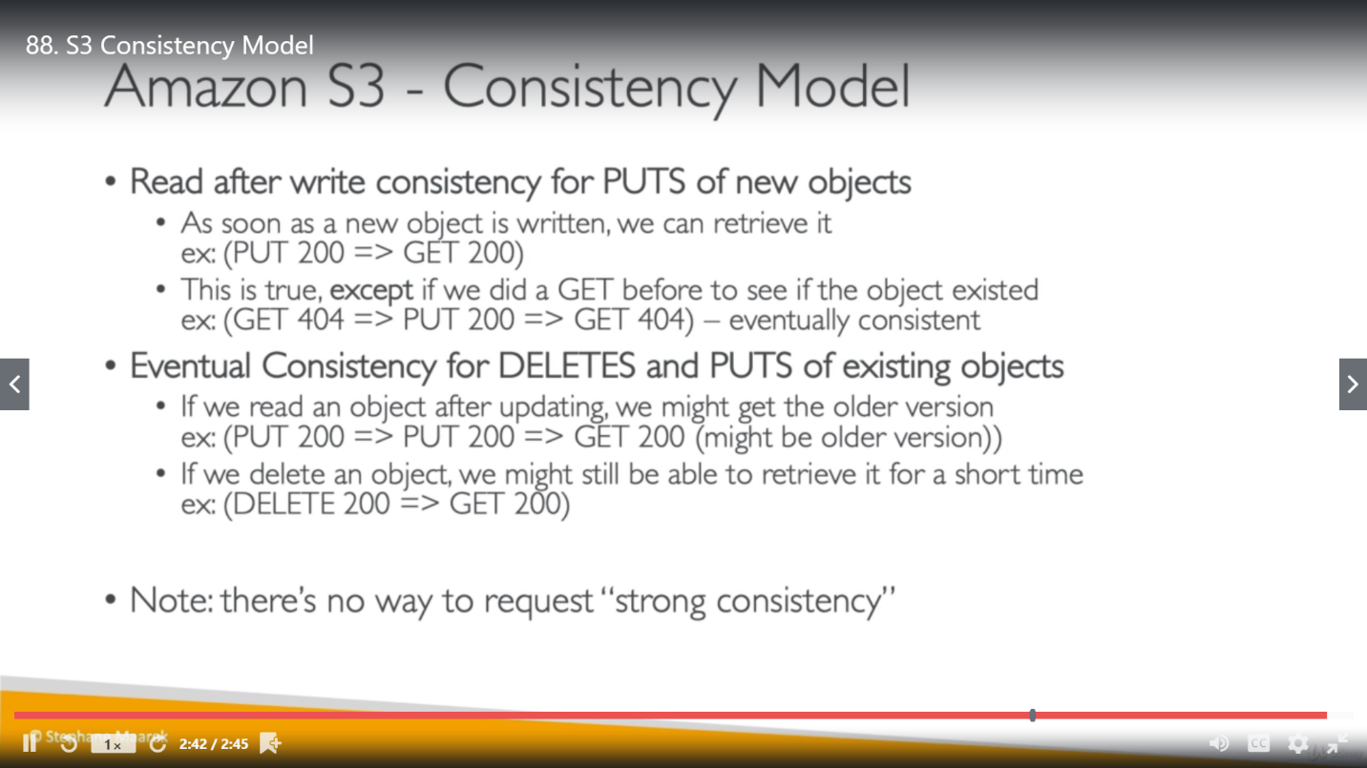

**QUIZ**

